

IT3060 - Human Computer Interaction

Assignment 1

Craigslist.org

2023-WE-S1-13

DreamWeave

**Member Details**

|  |  |  |
| --- | --- | --- |
| **Reg. No** | **Name** | **Work Distribution** |
| IT21181474 | Hettiarachchi H.K.Y. K | Identify the usability issues.  User Groups Identify  Make Gantt Chart  Contribute to make the report |
| IT21360046 | Jayasekara B.B.R.Y |  |
| IT21358616 | Munasingha M.H.C |  |
| IT21356636 | Perera P.K.L |  |
| IT21345746 | Siriwardana A.P.G.D.P |  |

# Table of Contents

1. Table of Contents 1

2. Project Description 2

3. Alternatives Considered 2

4. User groups identified. 3

5. Personas 3

6. Usability Issues 5

Accessibility 5

Identity 5

Content 5

7. Scripts for contextual inquiry 6

Craigslist.org: User Category – Undergraduate Student 6

Craigslist.org: User Category – Hotel Manager 6

Craigslist.org: User Category – Undergraduate Student 6

8. Sharable link of the upload video 7

9. Usability issues identified using contextual inquiry. 7

10. Ratings 8

11. Time Schedule (Gantt Chart) 9

12. References 9

13. Appendix 10

Hettiarachchi H.K.Y.K. 10

# Project Description

Our team chose the website called “Craigslist” the one of most well-known websites for online marketplace. The primary purpose of this website is to connect users within specific geographical areas, enabling them to post listings for items, services, housing, jobs and more. Users can explore listings, communicate with sellers through mail, and negotiate transactions directly. Its simplistic, Text-heavy interface and lack of modern designs (e.g. images etc.) can be occur as usability challenges for users.

# Alternatives Considered

We considered several alternative considerations. Our team members chose [Blinkee.com](https://blinkee.com/), [Chestertourist.com](http://www.chestertourist.com/) and [nh.craigslist.org](https://nh.craigslist.org/) websites. First, we chose blinkee.com but everyone is going to do that site because every requirement that has given by our module is fulfilled in that website. After considering the given instructions in our HCI module we came up with the **Craigslist** website.

# User groups identified.

User groups

Apartment Seekers

Job Hunters

Novice Sellers

Novice Sellers: Individuals who are new to the website trying to sell items.

Apartment Seekers: Users who are looking for rental housing.

Job Hunters: People searching for Job opportunities.

# Personas

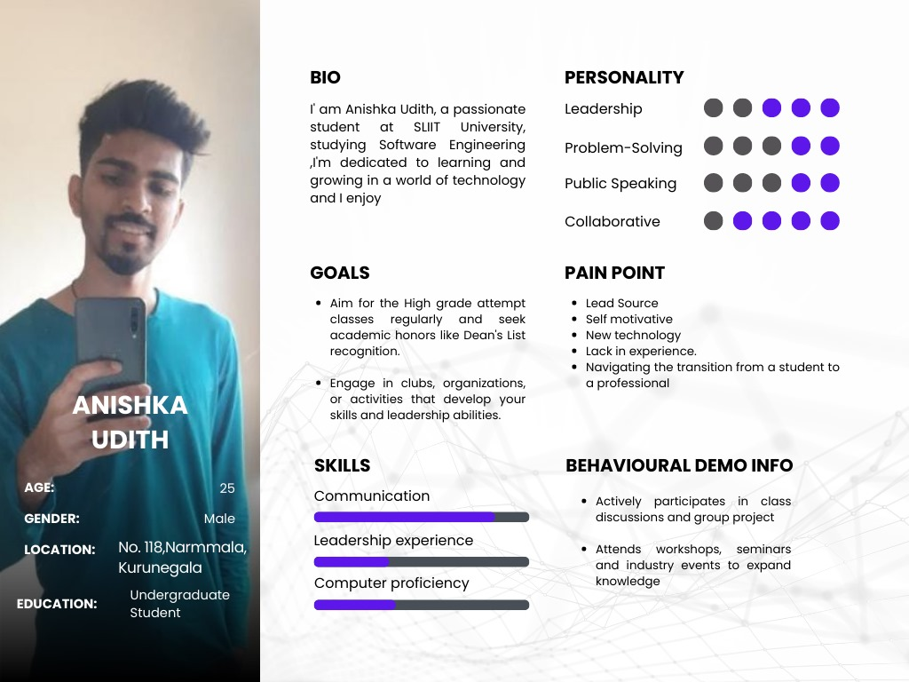

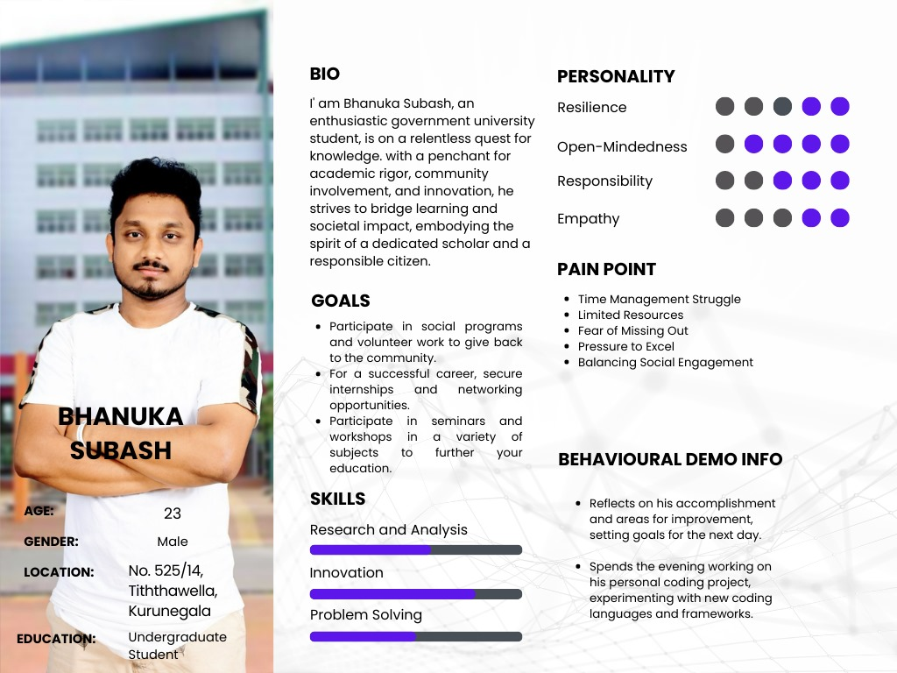

# Usability Issues

## Accessibility

* Confusing texts
* Navigations are hard to understand.
* No header
* Layout problems
* Not organized interfaces in an effect way.
* No back buttons.
* Any user can change the data on the website.

## Identity

* No usage of identity of the website
* No logo added.
* Confusing pages like feedback

## Content

* No affective color usage.
* Difficult to understand instructions and some content included on the website.
* The background color is not eye catching.

# Scripts for contextual inquiry

## Craigslist.org: User Category – Undergraduate Student

|  |  |  |
| --- | --- | --- |
| Background description of the user | Questions to be asked from the user | Tasks to be given to the user |
| Aniska Udith is a passionate student at SLIIT University. He is a person who is always willing to learn new technologies and get high grade classes. He is into a lot of different activities to show and improve his skills and qualifications. |  |  |

## Craigslist.org: User Category – Hotel Manager

|  |  |  |
| --- | --- | --- |
| Background description of the user | Questions to be asked from the user | Tasks to be given to the user |
| Sandalu Samarakoon is a hotel manager. He is a person who is committed to guest satisfaction. He is passionate to improve the productivity of his job role. |  |  |

## Craigslist.org: User Category – Undergraduate Student

|  |  |  |
| --- | --- | --- |
| Background description of the user | Questions to be asked from the user | Tasks to be given to the user |
| Bhanuka Subash is an enthusiastic government university student. He is a person who is always seeking opportunity to succeed in his career and secure his internship by enroll in a lot of different activities. |  |  |

# Sharable link of the upload video

[**http://bit.ly/userInterview**](http://bit.ly/userInterview)

# Usability issues identified using contextual inquiry.

# Ratings

# Time Schedule (Gantt Chart)

|  |  |  |  |  |  |
| --- | --- | --- | --- | --- | --- |
| Task | Week 1 | Week 2 | Week 3 | Week 4 | Week 5 |
| Group registration |  |  |  |  |  |
| Website Selection |  |  |  |  |  |
| Workload Distribution |  |  |  |  |  |
| Identify Usability Issues |  |  |  |  |  |
| Stakeholder Identification |  |  |  |  |  |
| Creating Personas |  |  |  |  |  |
| Creating Contextual Inquiry |  |  |  |  |  |
| Recording Videos |  |  |  |  |  |
| Make the Document |  |  |  |  |  |
| Submit Assignment 1 |  |  |  |  |  |

# References

# Appendix

## Hettiarachchi H.K.Y.K.

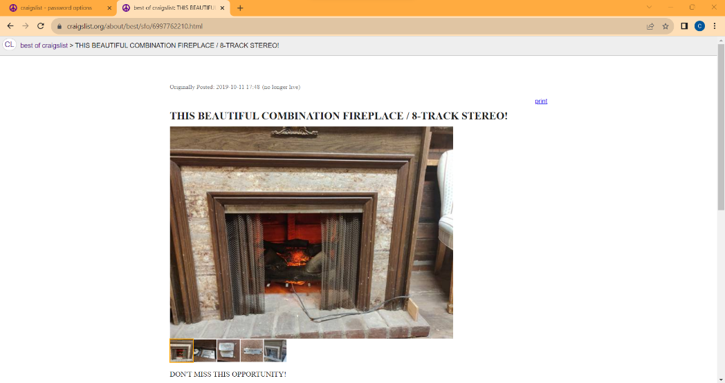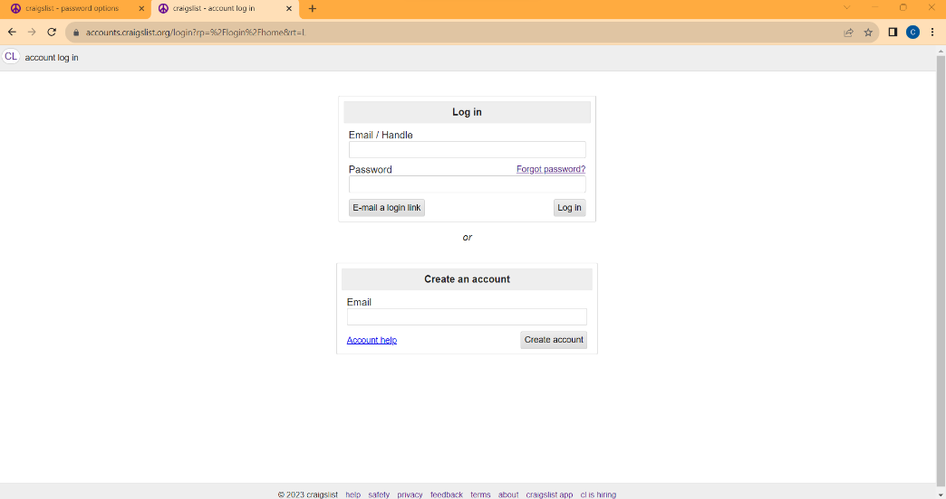IT21181474

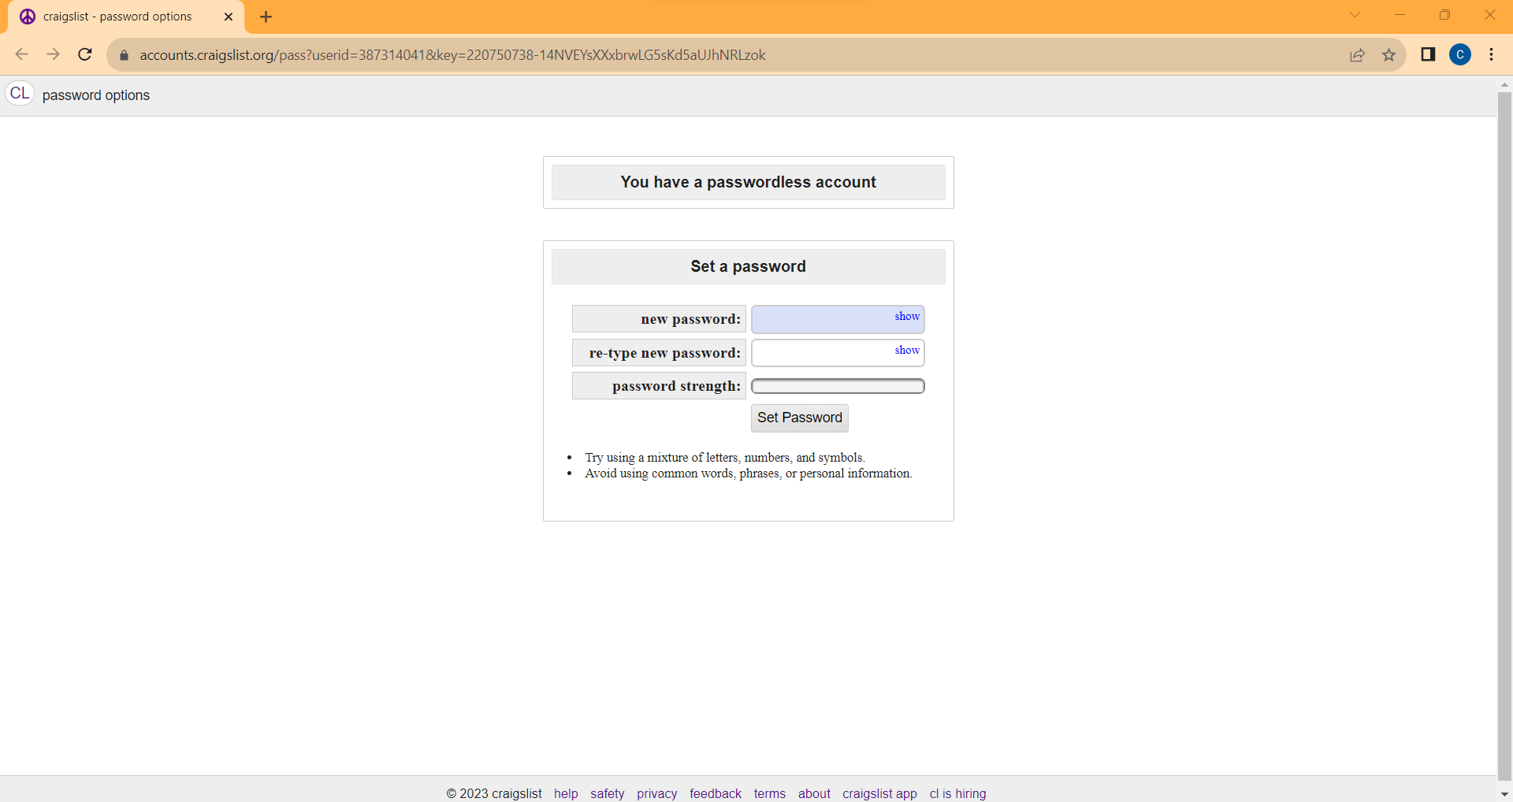

* about-> best of craigslist-> THIS BEAUTIFUL COMBINATION FIREPLACE / 8-TRACK STEREO!
* account log in
* password options